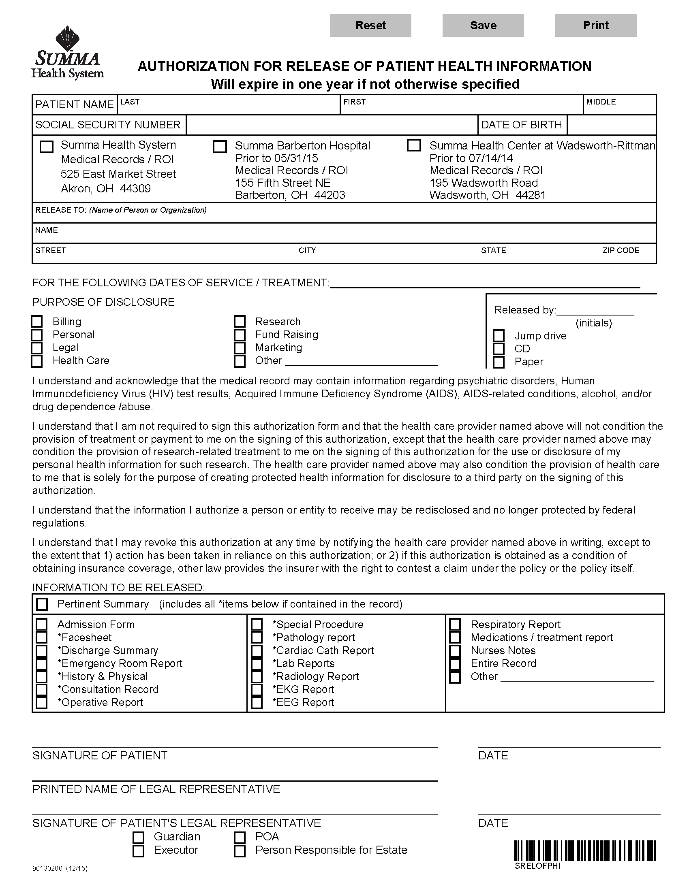
Batman
xxx-xx-5555
01/01/1979
Axiom Requisition Copy Service
2869 Jolly Road - Okemos, MI 48864 PH: (877) 886-5090 Fax: (517) 886-4116

X
FROM 01/01/1979 TO PRESENT: Any and all MEDICAL RECORDS, including but not limited to patient history form(s), reports, etc. pertaining to Batman SSN: xxx-xx-5555, DOB: 01/01/1979.

See Below

